DASH vSphere Redhat Openshift Access Guide

Input Guide
This section outlines the input parameters required for provisioning vSphere Redhat Openshift using the DASH portal. Each parameter includes a description, available options, usage guidance, and notes on valid combinations when applicable.
Input Parameter | Description | Values Provided | Value Guidance | Valid Combinations
deployment enclave | The physical hardware vendor where the VM is deployed. | cisco01, cisco02, hpe01, hpe02 | Cisco and HPE are the hardware vendors; choose the appropriate one based on your deployment requirements. | N/A
control plane | Master component that manages cluster state, schedules workloads, and orchestrates communication between nodes. | Control plane:  2, 3, 4, 5 | Choose control plane count based on availability & resilience needs. | N/A
worker nodes | Nodes that run application workloads (pods) and report back to the control plane. | Worker Nodes:  0, 1, 2, 3, 4, 5, 6 | Pick worker node count based on workload size, redundancy, and scaling requirements. | N/A
Services expire after 30 days. Create this service now, or schedule for a later date? | Cluster will be deleted 30 days after creation, or it can be scheduled to be created at a later date. | Create Now (or)  Schedule for Later | Choose based on Openshift cluster requirements. | N/A

Sample Input Selection:
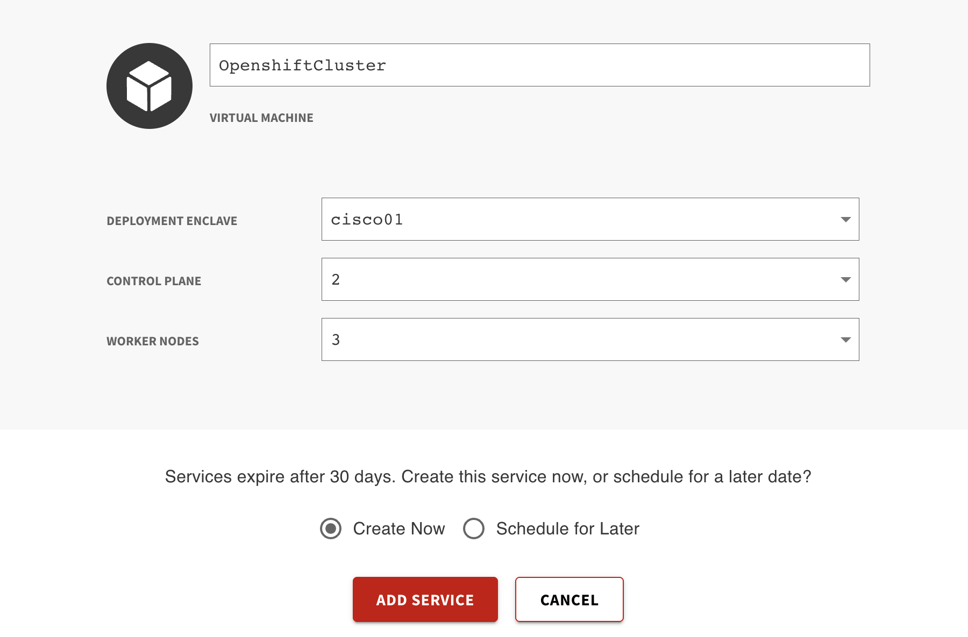

Output Guide
This section outlines the output values generated after vSphere Redhat Openshift provisioning through the DASH Portal. These outputs can be used to access, manage, and connect to your Openshift cluster.
Outputs | Description | Example Value
enclave | Dash enclave where the resources lives. | prj-8WbNLes4W88TJWEL
ip_address | The ip address of the boot VM that provisions the control and data planes. | 10.89.154.134
openshift_console_url | URL of the Openshift Cluster(accessible via browser). | https://console-openshift-console.apps.dash01-openshift.core.dash.cdwbuilt.com
openshift_password | Password used to log in to the OpenShift cluster through the web console. | K7aoG-86agK-abTd5-cnvY8
openshift_username | Username used to log in to the OpenShift cluster through the web console. | kubeadmin
ssh_password | Password to ssh to the boot VM that provisions the control and data planes. | MSkBrDV3
ssh_username | Username to login to the boot VM. | dash
vm_name | Name of the boot virtual machine created. | openshift-node-RLsG

What you can do with these outputs:
- Login to Boot Virtual Machine:

Use the following commands to connect to and manage your boot vSphere Virtual Machine that provisions the control and data planes. Replace placeholder values like <public_ip_address>, <ssh_username>, etc., with the actual outputs provided during provisioning.
1. SSH into the Virtual Machine (Linux-based OS)
Command:
ssh <ssh_username>@<public_ip_address>

Example:
ssh dash@10.89.154.134

- Login to Openshift console via browser:
- Copy paste the openshift_console_url in a web browser.
- Use the openshift_username and openshift_password provided to login to the cluster.

